Advanced Games Programming
Tutorial 07 - Additional Exercises
Name extra exercises Tutorial xx Extra yy, using appropriate xx and yy.

Extra Exercise 01

Most cameras have more controls than the simple ones in Exercise 1. Cameras can strafe, i.e. move sideways left or right while facing ahead. The diagram below illustrates the idea:

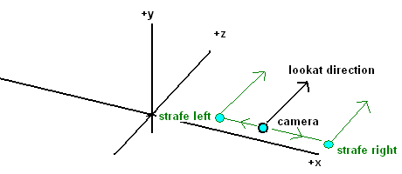

- Create a new project based on Tutorial 07 Exercise 01 called Tutorial 07 Extra 01.
- Work out the calculations required to strafe left and right - remember, the camera should move left and right relative to the lookat direction, not the axes. Implement strafing in your camera class, considering any additional variables you may need, what calculations to perform, and any shortcuts you might be able to use to simplify the calculations.

Advanced

Name advanced exercises Tutorial xx Advanced yy, using appropriate xx and yy.

Advanced Exercise 01

Cameras can also pitch - aiming upwards and downwards while pointing in the same ground direction. So if a camera was looking east along the ground, pitching upwards would result in it looking east towards the sky above the ground. The diagram below shows a side view of a camera, with the red arrow showing its original direction pointing directly down the positive x axis, and the blue arrows how it would end up after pitching up and down.
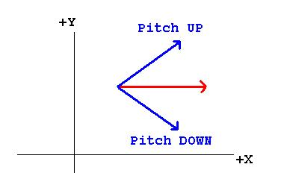
Use diagrams to work out the trigonometric equations necessary to implement pitch, and implement them in your camera class. You are not required to move the camera along the direction of view of the pitch, the forward and strafe functions can still move the camera around a horizontal xz plane.

You should populate your scene with many more cubes, and move around the scene to test the camera. Explore what happens with pitch angles above +-90 degrees - how can you solve this problem?

Additional Material

This is still a simple camera system; it doesn't allow full 3d movement (i.e. flying freely around the scene); it doesn't implement rolling (i.e. rotating around the view direction); it doesn't robustly set up the up vector, among others. If you wish to implement a better camera system I recommend you investigate the various ways of representing a camera, e.g. using Euler angles (as we have in these exercises), Matrix representation and Quaternions. Chapter 10 of:
Dunn, F. and Parberry, I. (2002), 3D Math Primer for Graphics and Game Development. Wordware Publishing Inc, US

gives an excellent overview and comparison of the various representations, along with their advantages and disadvantages.

